**Online Algorithm for Airport Management**

In this project we will implement an online algorithm which is based on an existing offline algorithm.

The online algorithm receives an optimal program of airplane takeoffs and landings for the workday, and during the day the algorithm will need to handle incidents and changes in real time. The main focus is to handle incidents and changes in real time with minimal deviation from the original program.

If the algorithm does not find a real time solution, it will send the existing situation with the constraint to the offline algorithm which will reprogram the program.

We developed the algorithm in the python environment based on the existing offline algorithm.

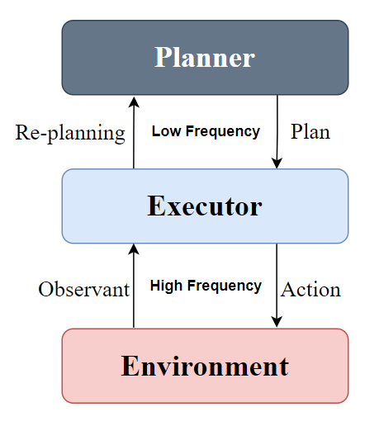The basis of the online algorithm should know to accept the offline algorithm data printout about the optimal program for airplane takeoff and landing times. In addition, it must be able to support the receipt of real time incidences and changes. It must also supply a decision about program continuation based on the incidents and changes.

